Project Design Phase-II
Technology Stack (Architecture & Stack)
Date | 31 January 2025
Team ID | SWTID-2026-6425
Project Name | EduGenie – AI-Powered Learning Assistant
Maximum Marks | 4 Marks

Technical Architecture:
The architecture includes the web interface, FastAPI application logic, separate learning feature modules, centralized Gemini service, validation layer and local application runtime.
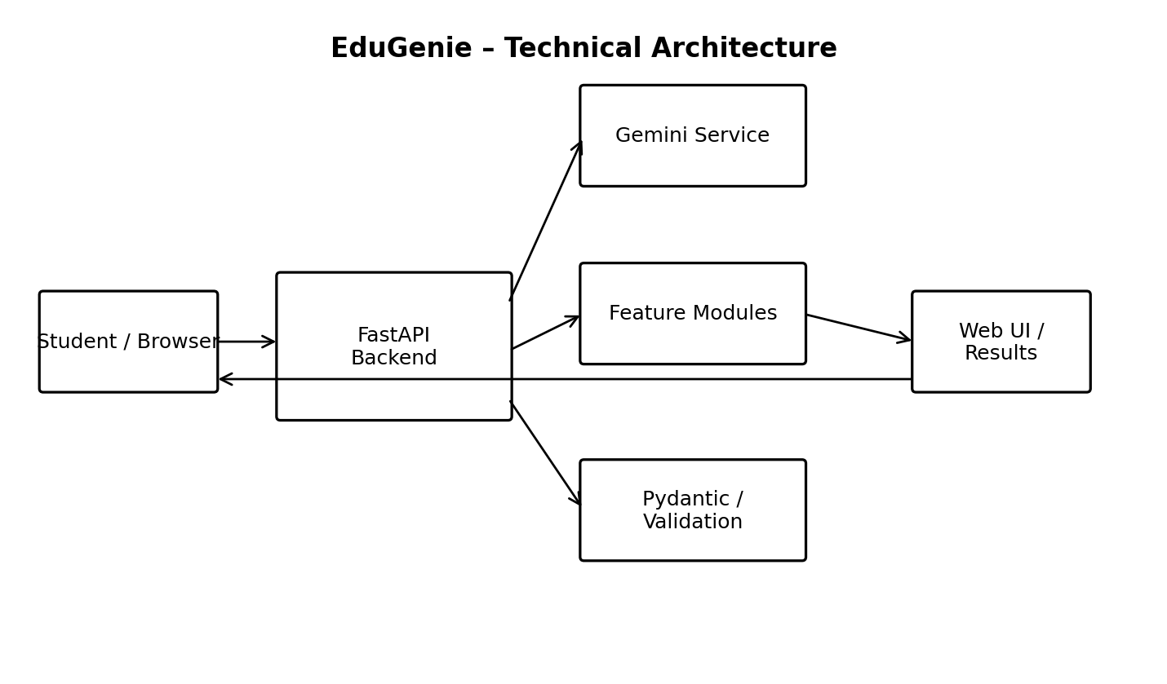
Table-1 : Components & Technologies:
S.No | Component | Description | Technology
1 | User Interface | Web interface used to select a learning task, enter input and view results. | HTML, CSS, JavaScript
2 | Application Logic-1 | Main backend routes and application entry point. | Python, FastAPI, Uvicorn
3 | Application Logic-2 | Question answering, topic explanation, quiz and summarization feature logic. | Python feature modules
4 | Application Logic-3 | Learning-path generation and centralized AI request handling. | Python, Gemini service
5 | Database | No application database is specified in the supplied EduGenie project. | Not specified
6 | Cloud Database | No cloud database is specified in the supplied EduGenie project. | Not specified
7 | File Storage | Project source, templates and static assets. | Local filesystem
8 | External API-1 | AI content generation for learning features. | Google Gemini API
9 | External API-2 | No second external API is specified in the supplied project. | Not specified
10 | Machine Learning Model | Generates answers, explanations, quizzes, summaries and learning recommendations. | Google Gemini model
11 | Infrastructure (Server / Cloud) | Application runtime for local development. | Uvicorn on 127.0.0.1:8000
Table-2: Application Characteristics:
S.No | Characteristics | Description | Technology
1 | Open-Source Frameworks | Open-source web/backend frameworks used by the application. | FastAPI, Uvicorn, Jinja2, Pydantic
2 | Security Implementations | Gemini API key is kept on the backend and loaded through environment configuration. | .env / environment variables
3 | Scalable Architecture | Learning features are separated into individual modules and Gemini integration is centralized. | Modular FastAPI architecture
4 | Availability | Health status can be checked through the application health endpoint. | FastAPI /health
5 | Performance | Modular requests and structured response validation keep each learning task focused. | FastAPI, Pydantic, Gemini
References:
EduGenie project documentation and supplied project source structure.

